*Name: Alexander Balandin*

*ID: 132145194*

*DATA: 10/29/2020*

*Heroku url: https://glacial-eyrie-05995.herokuapp.com/*

--Home page:

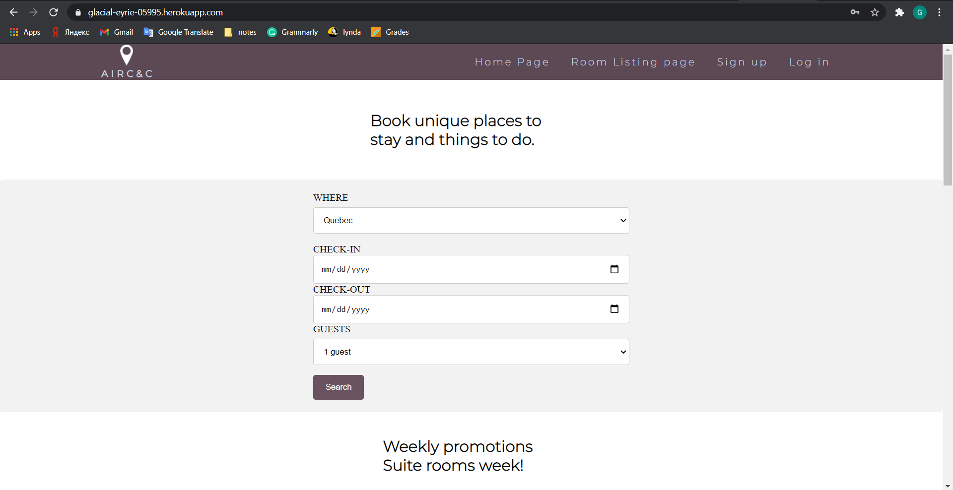

--Promotions:

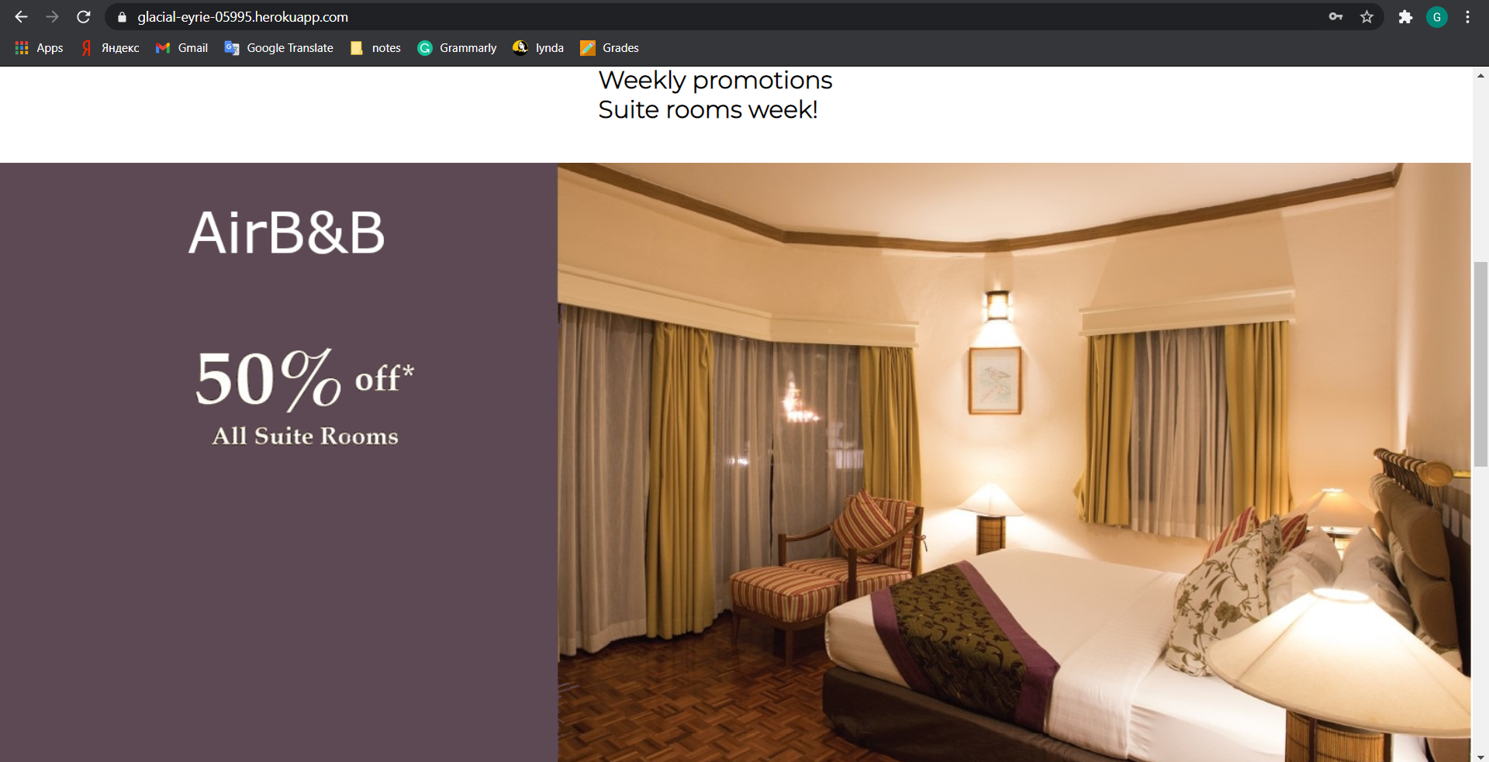

--Information for the user:

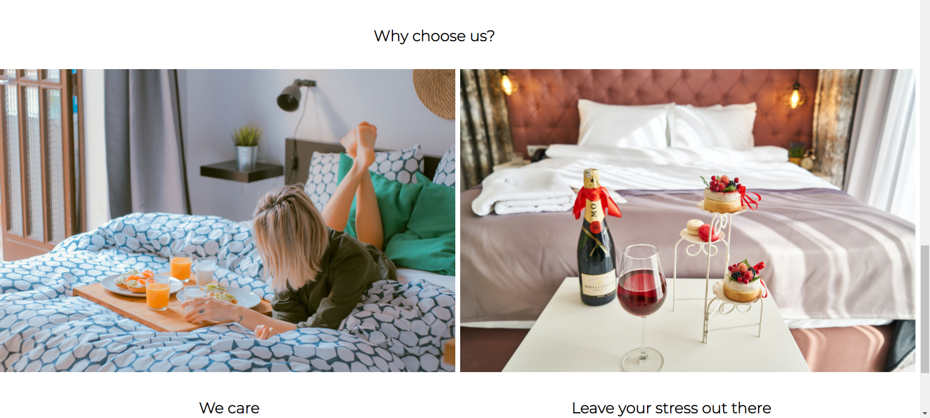

--The website supports a mobile version. If the user’s screen is lower than 768 px, the navigation bar will be hidden into the burger button.



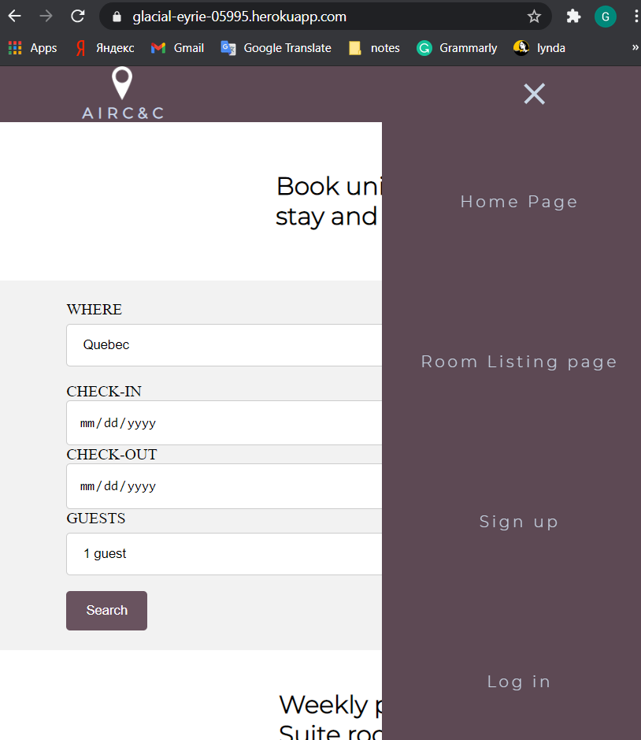

--Room listing page with six offers to the user:

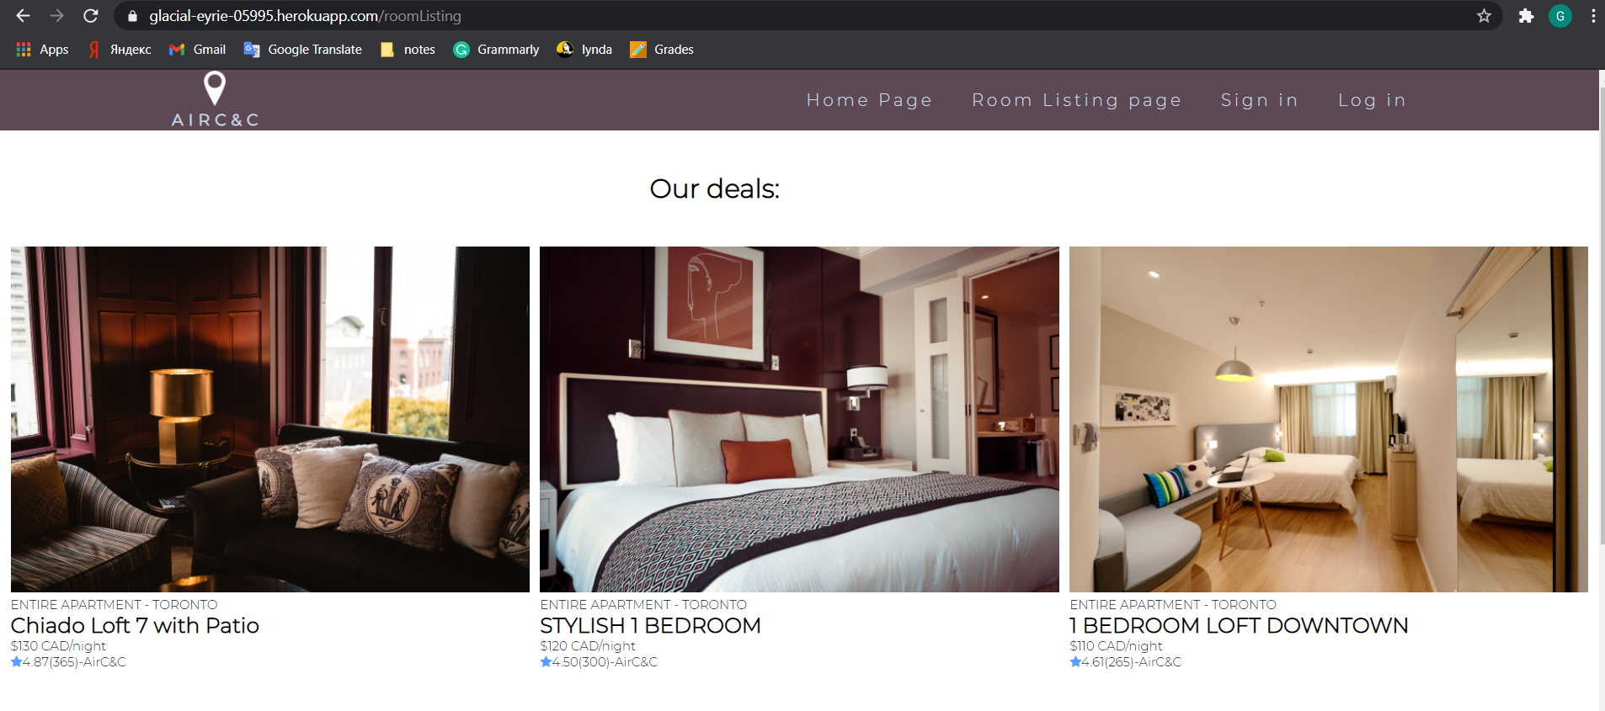

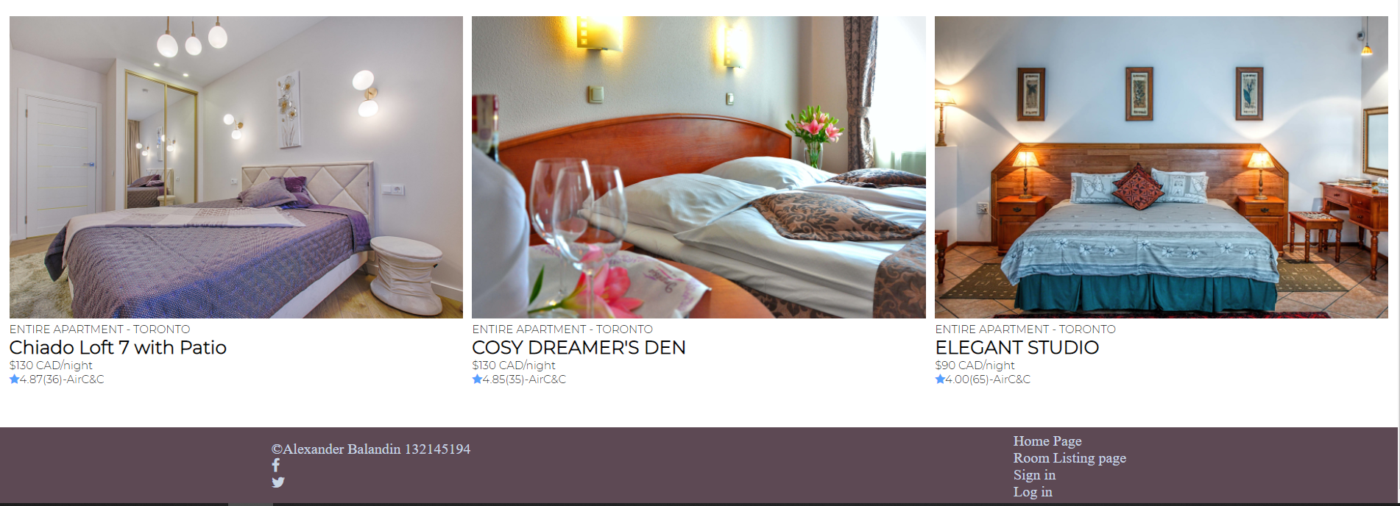

--Sign up page:

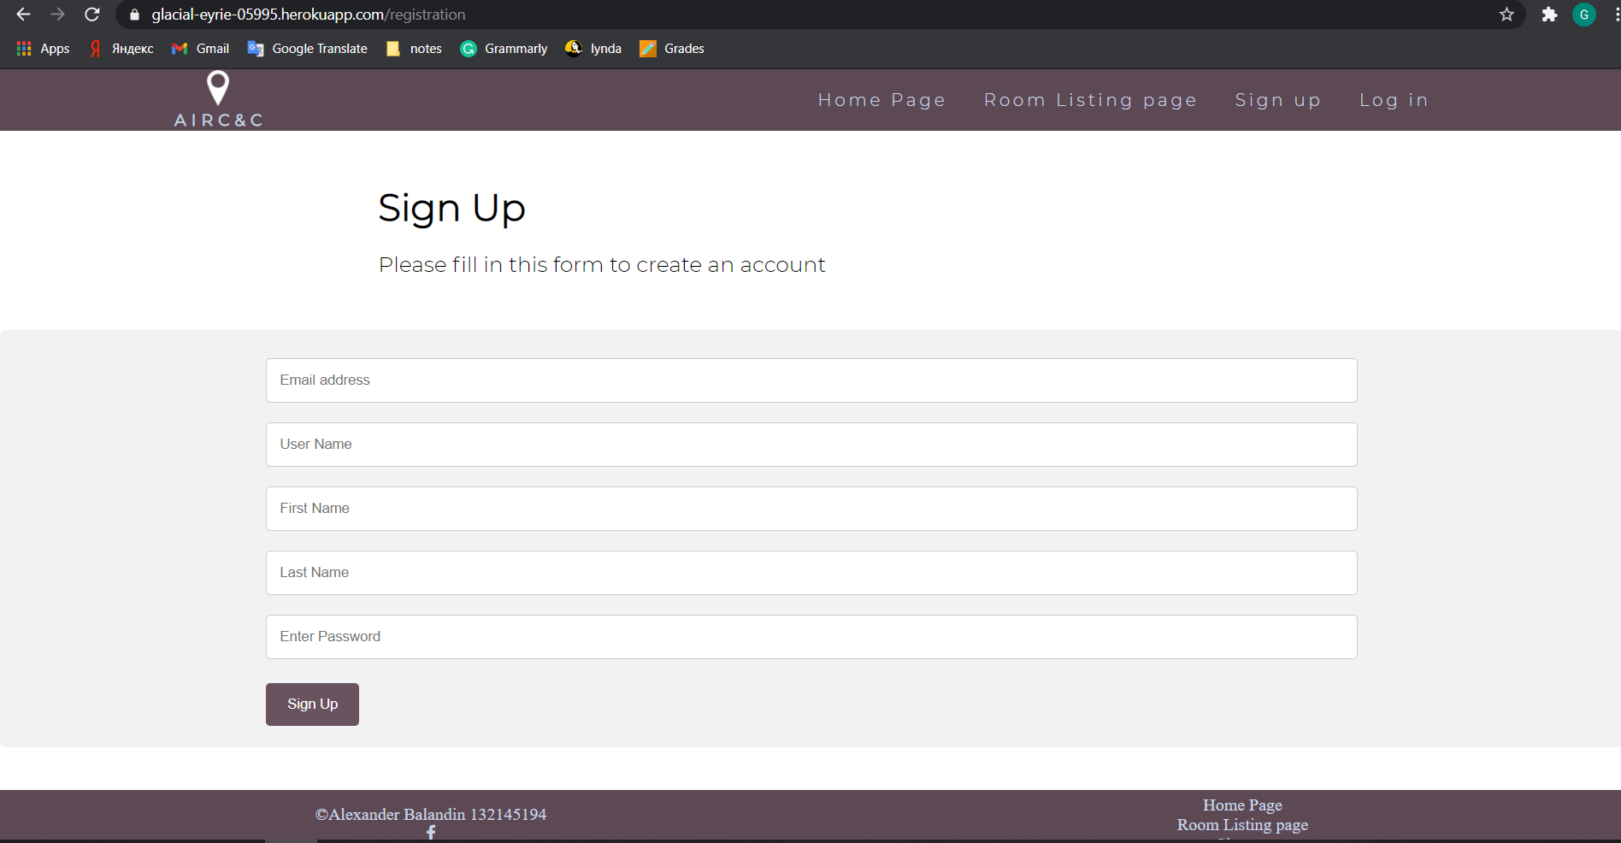

--All validation is done on the server side. To submit the form, email must contain @ sign, and a password must contain at least one number, lowercase, and uppercase letters, and have a length from 6 to 12 characters. Also, there must not be empty fields as they are all required.

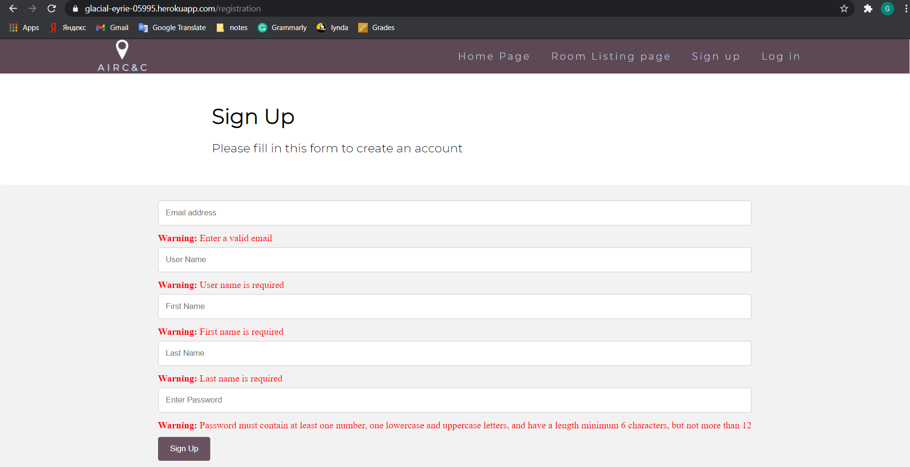

--The dashboard (or welcome message) appears after a successful submission, and the message greetings the new user by its **username.**

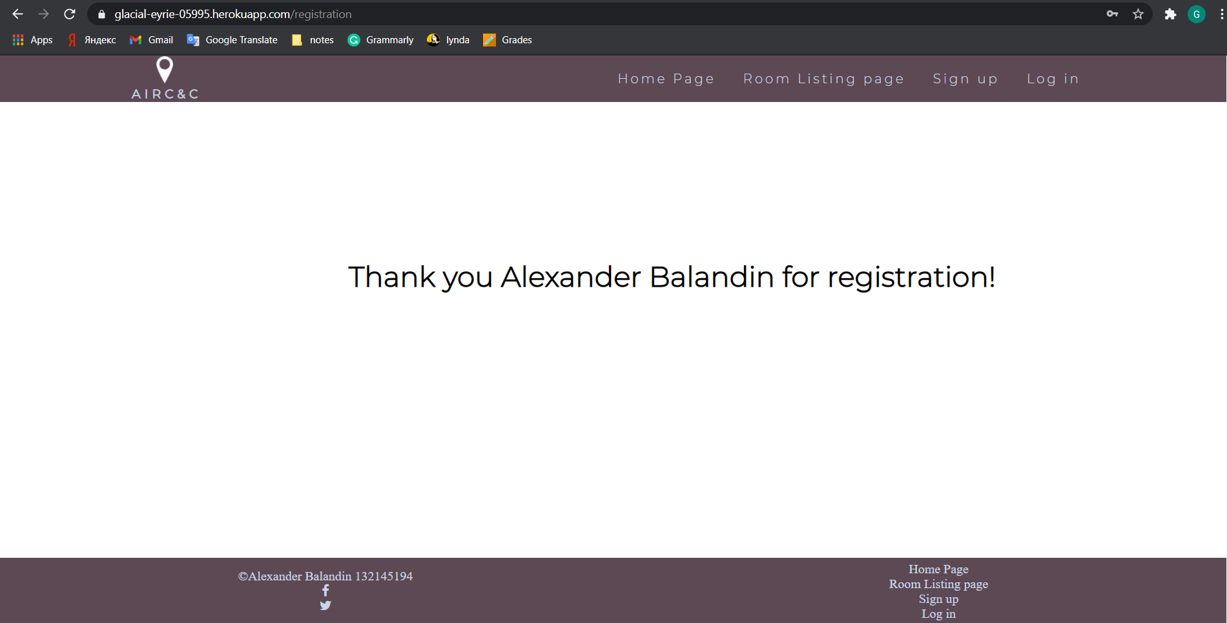

--login page checks only for nulls on the server-side.

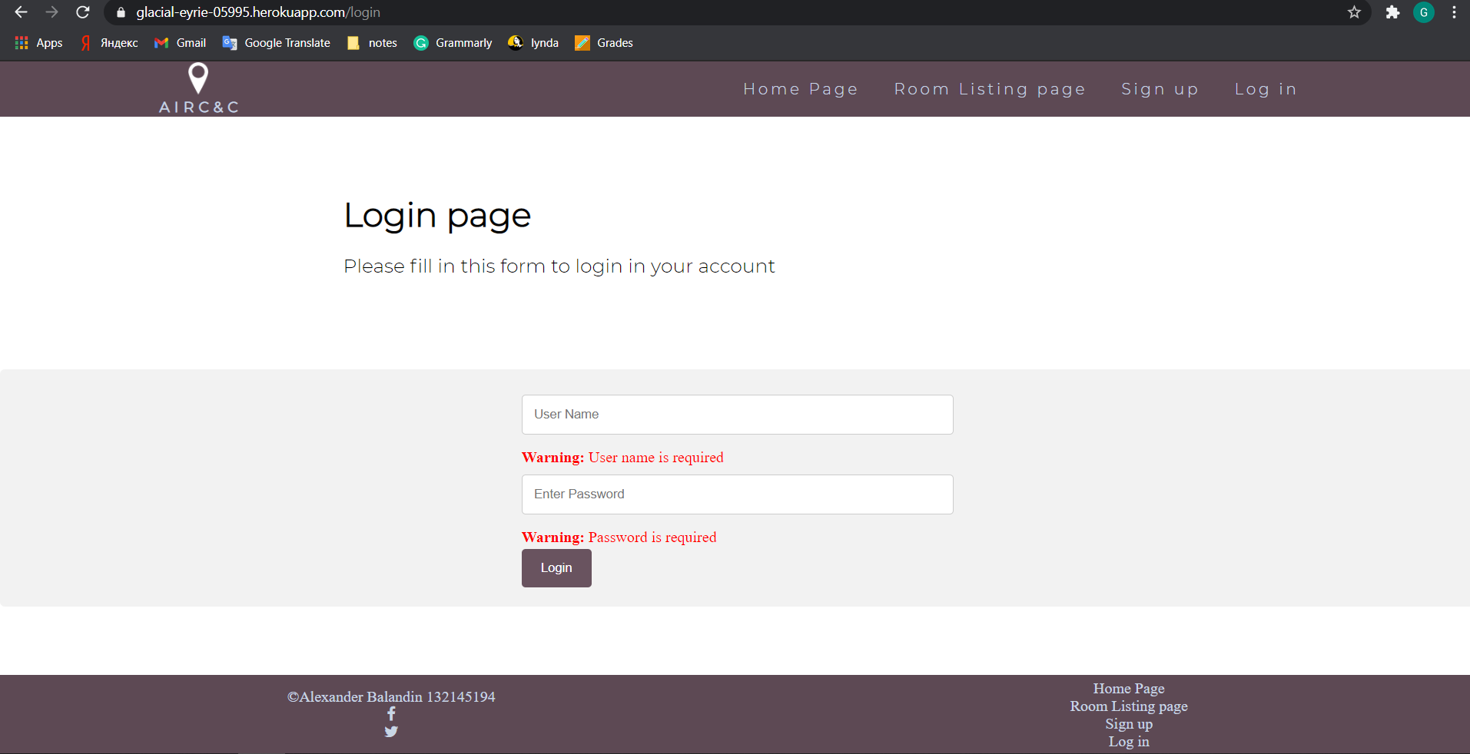

--After the submission, the user redirects to the dashboard, that displays the message according to its **username**

